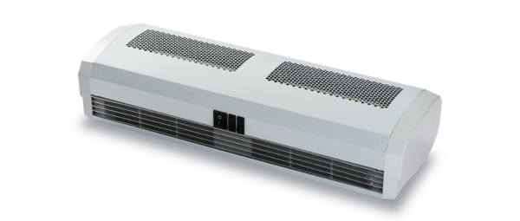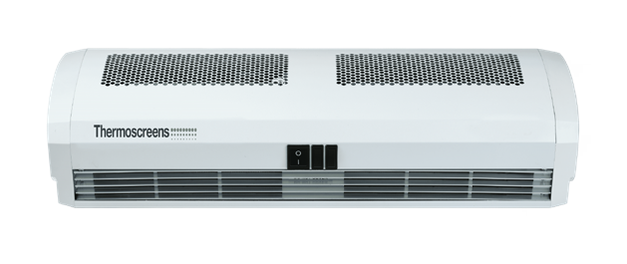Specification Text / Tender Text

Jet Series - Over Door Heater
Overdoor heaters for lightly trafficked doorways.

Casing

Pressed curved front panel with a punched air inlet grille. The casing is fabricated out of 1.0mm laminated steel construction contoured to prevent distortion and drumming.

Outlet / Discharge Grills

Aluminium pressed grille to rectify the airstream coming out the product. End Caps
Injection moulded endcaps to fully encapsulate the product, colour matched to main
body.

Fans

A twin shafted shaded pole single speed motor drives two tangential impellers to
provide the airflow required.

Controls

Factory mounted intelligent purpose built over door heater controller with the following features:
- 7 day timer function
- Adaptive start
- Built in thermostatic control Filters
A woven plastic mesh over welded metal frame filter is inserted to sit on top of the air intake grille to reduce the ingress of dirt and dust, protecting the unit’s internals.

Electric Heating Elements
Stitched electrical elements incorporating a protective overheat device, resettable when the supply is isolated.

Ceiling Mounting Bracket

Cold rolled mild steel powder coated wall bracket finished to colour match the unit’s
casing to allow installation of the unit in line with the installation instructions.

IF YOU ARE LOOKING FOR MORE INFORMATION YOU CAN ASK OUR DEDICATED TEAM OR DOWNLOAD OUR BROCHURE AND MANUAL.

CLICK TO SPEAK TO TEAM CLICK TO DOWNLOAD THE BROCHURE
CLICK TO DOWNLOAD THE MANUAL

+44 (0) 24 7638 4646

SALES@THERMOSCREENS.COM WWW.THERMOSCREENS.COM
Thermoscreens Limited St Mary’s Road, Nuneaton, Warwickshire CV11 5AU

Part of

