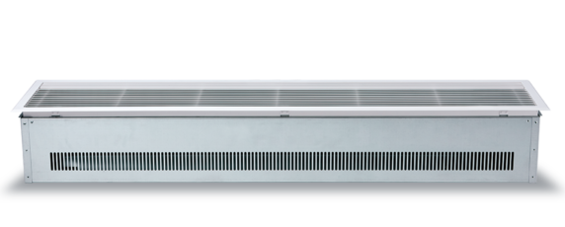

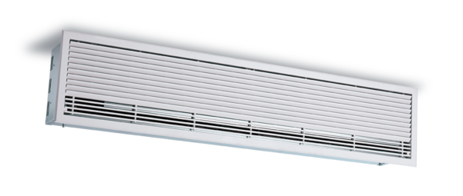Specification Text / Tender Text

Compact 2 - Recessed Mounted
Quiet, stylish and easy to install.

Coils
Units with water heating coils are manufactured from copper tube, mechanically expanded to die cut aluminium fins with female BSP connections. Factory tested to 20 bar air under water testing and rated for working pressures of up to 8 bar. Externally mounted mid-position valve offers no heat (ambient), half heat or full heat settings.

Casing
Galvanised steel enclosure with stiffening bars to provide rigidity to the unit and to
prevent distortion and drumming.

Outlet / Discharge Grills
The grille is a powder coated aluminium grille that serves as a hinged access panel for
maintenance.

Fans
Each unit has a twisted tangential fan powered by a 4 pole AC split phase capacitor motor with integral thermal protection. The high specification motors incorporate “sealed for life” bearings, are anti-vibration mounted to give an expected life in excess of 40,000 running hours. Connection is via a plug in connector in the unlikely event of needing to be removed.

Controls
The C2 Series uses a factory installed intelligent, controller with the following features included:
- Multiple fan speed selection - 3 speeds available
- Multiple heating level selection - 3 levels available (Water and Electric units only)
- Dry contact for supervisory system connection or door switch
- Programmable input for air temperature thermostat
- Thermal protection reset
- Master/slave control
- Wall Controller - Durable injection moulded ABS housing, contains the printed circuit board. Rubberised buttons to provide user adjustment of 3 fan speeds, 3 heat levels, on/off switch and automatic/manual heating control.
- Optional Modbus and Bacnet interface module for easy connection to a BMS
system.

Electric Heating Elements (Electric Units Only)
Factory installed and wired, thermally protected and constructed with a galvanised steel frame, with helical coil suspended elements. Elements are typically powered with 3 phase with single phase options available on request.

Ceiling Mounting Bracket
The unit is supplied with holes and internal bracketry to allow the unit to be ceiling
mounted on M6 drop rods.

IF YOU ARE LOOKING FOR MORE INFORMATION YOU CAN ASK OUR DEDICATED TEAM OR DOWNLOAD OUR BROCHURE AND MANUAL.

CLICK TO SPEAK TO TEAM CLICK TO DOWNLOAD THE BROCHURE
CLICK TO DOWNLOAD THE MANUAL

+44 (0) 24 7638 4646

SALES@THERMOSCREENS.COM WWW.THERMOSCREENS.COM
Thermoscreens Limited St Mary’s Road, Nuneaton, Warwickshire CV11 5AU

Part of

